Questions to Answer

1. Initial Thoughts (2 points)
Discuss your initial thoughts on designing QueueSmart:
- Who are the main users of the system?
Users and administrators
- How will users and administrators interact with the application?
User side:
Open up the webpage to register or log in
After registering or logging in they can view the queues
User then can join the queues or leave these queues
User can view current position and wait time in each queue
User will get notified when close to being served or queue status changes
User can view history of past queues
Administrators side:
Open up the webpage to register or log in
After registering or logging in they can view the queues and manage them
Administrators can monitor queue activity
Administrators can create new queues and give it a name and description and
service duration and a priority level
Administrators can view usage statics
- What are the most important features?
Basic authentication when logging in and registering
Administrator creating new queues
Keeping track of users and their wait time and managing priority queues
Notification alerts
Queue history
Usage data for administrator
- What challenges do you anticipate (e.g., long queues, notifications, inaccurate wait times)?
Priority ordering
Updates of queues changing
Features only being accessible by role

2. Development Methodology (2 points)
Discuss the development methodology your team plans to use:
- Which methodology will you follow (e.g., Agile, Scrum, Waterfall)?
Agile
- Why is this methodology appropriate for this project?
- The Agile development process is a lightweight, highly iterative approach to software design in which code is developed and tested in small increments. Each small piece of functionality is continuously tested to ensure that it works correctly before additional features are added. This will help when developing the different parts of the Administrative and User elements which each have smaller pieces in it. This allows the development team to collaborate effectively and have confidence that the existing code works before building upon it.

- How will this approach help your team work across multiple assignments?

This approach will allow each team member to clearly communicate the additions they have implemented and explain what each addition does. Because each addition will be developed and tested iteratively, the team can reduce confusion and identify problems before moving on to the next part of the project. This will make it easier for team members to communicate about what has been completed, what is currently being worked on, and what the overall goal of each assignment is.

3. High-Level Design / Architecture (6 points)
Provide a high-level architecture of your proposed solution.
Your response must include:
- An architecture diagram
- A brief explanation of how the major components interact
System Context Diagram
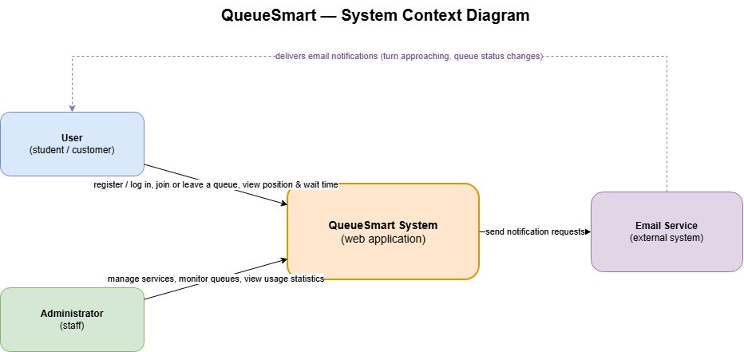
This diagram shows QueueSmart as one single system, and who interacts with it from outside.
- User (student / customer): User register and log in on a web page. They can join or leave the queue, and check their current position and estimated wait time.
- Administrator (staff): Admin log in and create services (name, description, expected duration, priority level). They also monitor queues and view usage statistics.
- QueueSmart System: This is a web application itself. It handles authentication, keeps queue order by arrival time and priority, estimates wait time, and saves each user's queue history. Only this part is inside the system boundary.
- Email Service (external system): QueueSmart does not send email by itself. When a user is close to being served or queue status changes, QueueSmart sends notification requests to external email service, and that service delivers email to the user. In-app notification is shown by QueueSmart directly, so only email delivery depends on the outside system.
So users, administrators and email service are outside of the system. They only interact with QueueSmart by log in, viewing pages, and notification.
Container Diagram 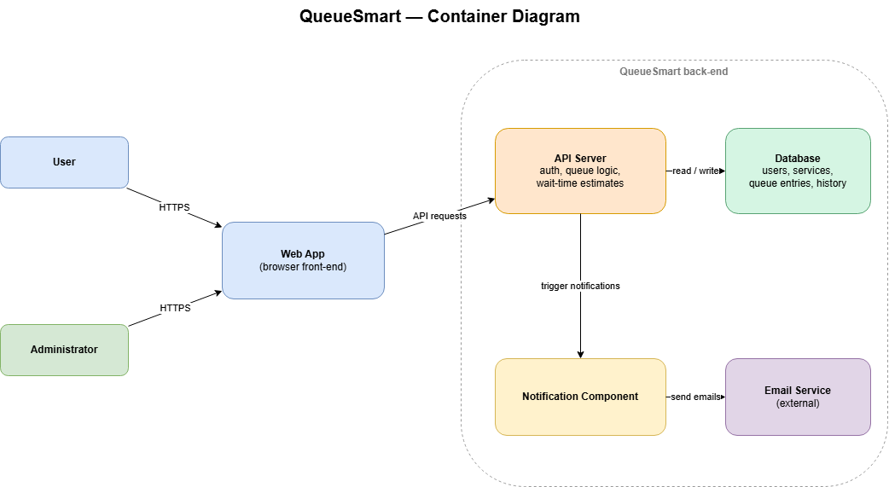
This diagram shows the major parts inside QueueSmart and how they communicate with each other.
- Web Application: This is the interface that users and administrators access through a browser. It displays queue and administration pages and sends their requests to the API Server.
- API Server: This is the main back-end component. It handles authentication and user roles, processes queue actions such as joining and leaving, determines queue order based on arrival time and priority, and calculates estimated wait times.
- Database: The database stores user accounts, services, active queue entries, and queue participation history. The API Server reads and updates this information.
- Notification Component: The API Server triggers this component when a user’s turn is approaching or when the queue status changes. It creates in-app notifications and sends email requests to the external Email Service. It can also request verification emails during registration.
A typical flow begins when a user joins a queue through the Web Application. The Web Application sends the request to the API Server, which saves the queue entry in the Database and recalculates the queue positions. When the user’s turn is approaching, the API Server triggers the Notification Component. The component updates the in-app notification and asks the external Email Service to deliver an email.
Database Schema & Data Models
To support the database container, the system uses four main tables to store and track information:
- Users Table (users) — Stores accounts for both students and administrators.
  - user_id (Primary Key): Unique ID for each user.
  - email: The user's email address for login and notifications.
  - password_hash: Securely encrypted password.
  - role: Identifies whether the user is a student or an admin.
- Services / Queues Table (services) — Stores the different queues created by administrators.
  - service_id (Primary Key): Unique ID for each queue/service.
  - name: The name of the queue (e.g., "Financial Aid").
  - description: Short description of the service.
  - expected_duration_minutes: Estimated time it takes to serve one person.
  - priority_level: Defines the priority rules for the queue.
- Queue Entries Table (queue_entries) — Tracks users who are currently waiting in a queue.
  - entry_id (Primary Key): Unique ID for the queue ticket.
  - service_id (Foreign Key): Links to the specific queue.
  - user_id (Foreign Key): Links to the user waiting in line.
  - joined_at: Timestamp of when the user joined.
  - status: Tracks their current state (e.g., waiting, serving, completed).
- History Table (queue_history) — Saves past queue participation records for users.
  - history_id (Primary Key): Unique ID for the history record.
  - user_id (Foreign Key): Links to the user.
  - service_id (Foreign Key): Links to the service they used.
  - total_wait_time: How long they waited in total.
  - completed_at: Timestamp of when their service finished.

Team Contribution Requirement (IMPORTANT)
You must clearly document each team member’s contribution.
TAs will verify contributions using GitHub history.
Team members who do not show meaningful contributions will receive a ZERO.
Group Member Name | What is your contribution? | Discussion Notes
1 Alan Pourmo | Answered all the  Questions in part 1 initial thoughts
2 Dakoda Small
3 Jihoon Lee | Answered part 3: system context & container diagram and architecture explanation
4 Maham Mubbashir | Expanded Part 3 by adding the complete relational database schema and data models to support the container architecture | Added the database schema to Part 3 since parts 1, 2, and 3 were already completed by the other team members

